**ANALYSIS OF SHOP MANGEMENT SYSTEM**

### A PROJECT REPORT

***Submitted by***

**R. Bhargav ram, A. Sriveda**

**192210120,192210530**

*Under the guidance of*

**Dr. Monika. E**

(Professor, Department of Deep Learning)

***In partial fulfillment for the completion of course CSA0830- Theory of Computation with Ambiguity***



**SIMATS ENGINEERING**

**THANDALAM**

**MARCH 2024**

## BONAFIDE CERTIFICATE

Certified that this project report titled “**SHOP MANGEMENT SYSTEM**” is the bonafide work of “**R.BHARGAVRAM, A.SRIVEDA”**who carried out the project work under my supervision as a batch. Certified further, that to the best of my knowledge the work reported herein does not form any other project report .

Date : Head of the Department

Project Supervisor

|  |  |  |
| --- | --- | --- |
| **S.NO** | **CONTENT** | **PAGE.NO:** |
| 1. | ABSTRACT | 4 |
| 2. | INTRODUCTION | 4-5 |
| 3. | METHODOLOGY | 5 |
| 4. | ALGORITHM | 6 |
| 5. | ALGORITHM STEPS | 7 |
| 6. | CODE EXPLANATION | 8-9 |
| 7. | RESULTS | 10 |
| 8. | DISCUSSIONS | 10-11 |
| 9. | OUTPUT | 12 |
| 10. | CONCLUSION | 12-13 |
| 11. | REFERENCES | 13-14 |

1. **ABSTRACT:**

In today's retail world, effective management of store operations is critical for long-term success. A shop management system (SMS) emerges as a critical solution, providing complete capabilities that include managing stock and checkout processes to sales reporting, customer relationship management, and multi-channel connectivity. SMS improves operations, customer satisfaction, and profitability by automating procedures and providing useful data. This summary summarizes the significance of SMS among multiple retail events.

**Keywords**: Shop management System[SMS] , Inventory Management, Point of Sale, Customer Relationship Management , Efficiency, Retail Operation, Profitability.

1. **INTRODUCTION:**

A shop management system is a software solution that improves operations and increases productivity in retail organizations. It includes capabilities including inventory management, point-of-sale transactions, sales reporting, customer relationship management, employee scheduling, and multi-channel connectivity. By automating chores and offering useful insights into sales and inventory data, these technologies enable retailers to streamline their operations, improve customer service, and increase profitability. From tiny independent stores to huge retail chains, having a shop management system is vital for staying competitive and addressing the changing demands of today's retail industry.

**Project scope:**

**Inventory Management:** Tracking and managing stock levels, product details, and supplier information.

**Point of Sale (POS):** Facilitating transactions, including sales, returns, exchanges, and payment processing.

**Sales Reporting and Analytics**: Generating reports, analyzing sales data, and identifying trends to inform decision-making.

**Customer Relationship Management(CRM):** Managing customer information, preferences, and interactions to improve service and loyalty.

**Employee Management:** Scheduling, tracking hours, and monitoring performance metrics to optimize workforce efficiency.

**Multi-channel Integration:** Seamlessly synchronizing inventory and orders across various sales channels, including online platforms.

**Security and Compliance:** Implementing measures to safeguard sensitive data and ensure adherence to industry standards.

**3. METHODOLOGY:**

The methodology for slab-based electricity billing involves several key steps:

**Define Slabs:** The first step is to establish the different consumption tiers or slabs. These slabs can be based on factors such as total usage per billing period or time of day.

**Determine Rates:** Once the slabs are defined, corresponding rates for each slab need to be determined. Typically, higher consumption tiers incur higher rates per unit of electricity.

**Metering:** Accurate metering is essential for slab-based billing to ensure that consumption is correctly allocated to the appropriate tier. Advanced metering technologies, such as smart meters, may be employed for this purpose.

**Consumption Calculation:** Based on the recorded consumption data from meters, the utility calculates the total consumption for each billing period and assigns it to the corresponding slab.

**Billing Calculation:** The final step involves calculating the total charge for electricity consumption by summing the charges for each slab. This may also include additional fees or taxes.

**4.ALGORITHM:**

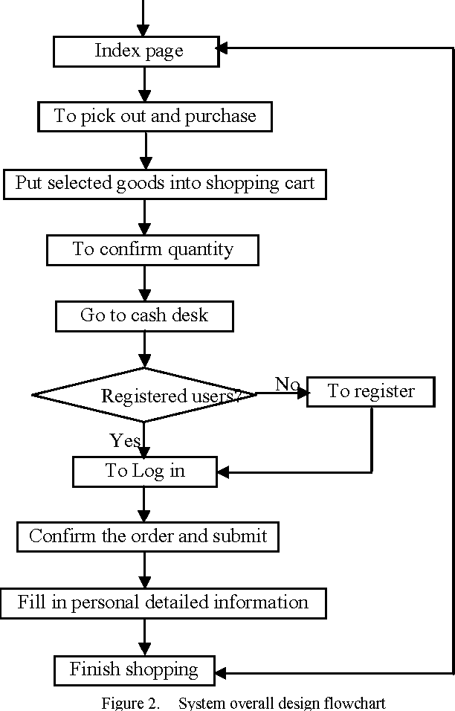

**5.ALGORITHM STEPS:**

* Pick out and purchase: This is the starting point of the flowchart, where a customer begins shopping.
* Put selected goods into shopping cart: After browsing, a customer can add items to their virtual shopping cart.
* To confirm quantity: This step allows the customer to review the items in their cart and adjust the quantities if needed.
* Go to cash desk: Once the customer is satisfied with their selections, they can proceed to the checkout process.
* Registered users: The flowchart then splits into two paths, depending on whether the customer has an account with the store.
* Yes: If the customer is a registered user, they can proceed to log in.
* No: If the customer is not a registered user, they will need to create an account before continuing.
* To register: If the customer doesn’t have an account, they can take this path to register.
* To Log in: Registered users can log in to their account at this step.
* Confirm the order and submit: After logging in or registering, the customer can confirm their order and submit it for payment processing.
* Fill in personal detailed information: During checkout, the customer will need to provide their personal details for billing and shipping purposes.
* Finish shopping: Once the payment is processed and the order is confirmed, the shopping process is complete.

**6.CODE EXPLANATION:**

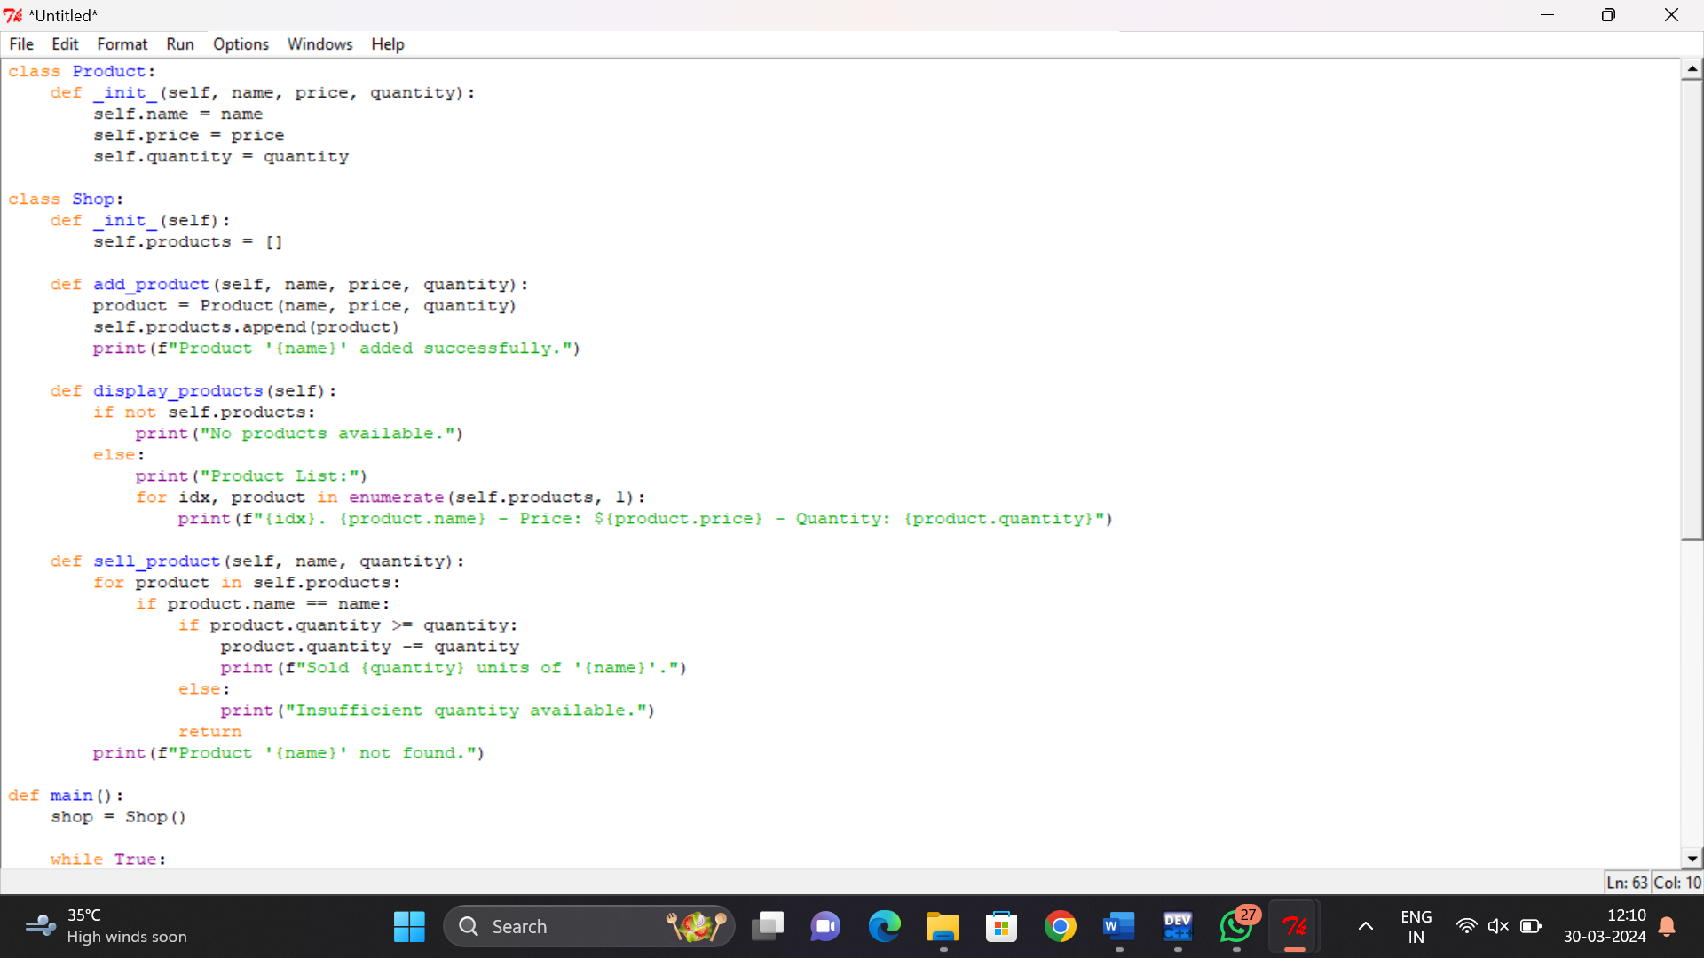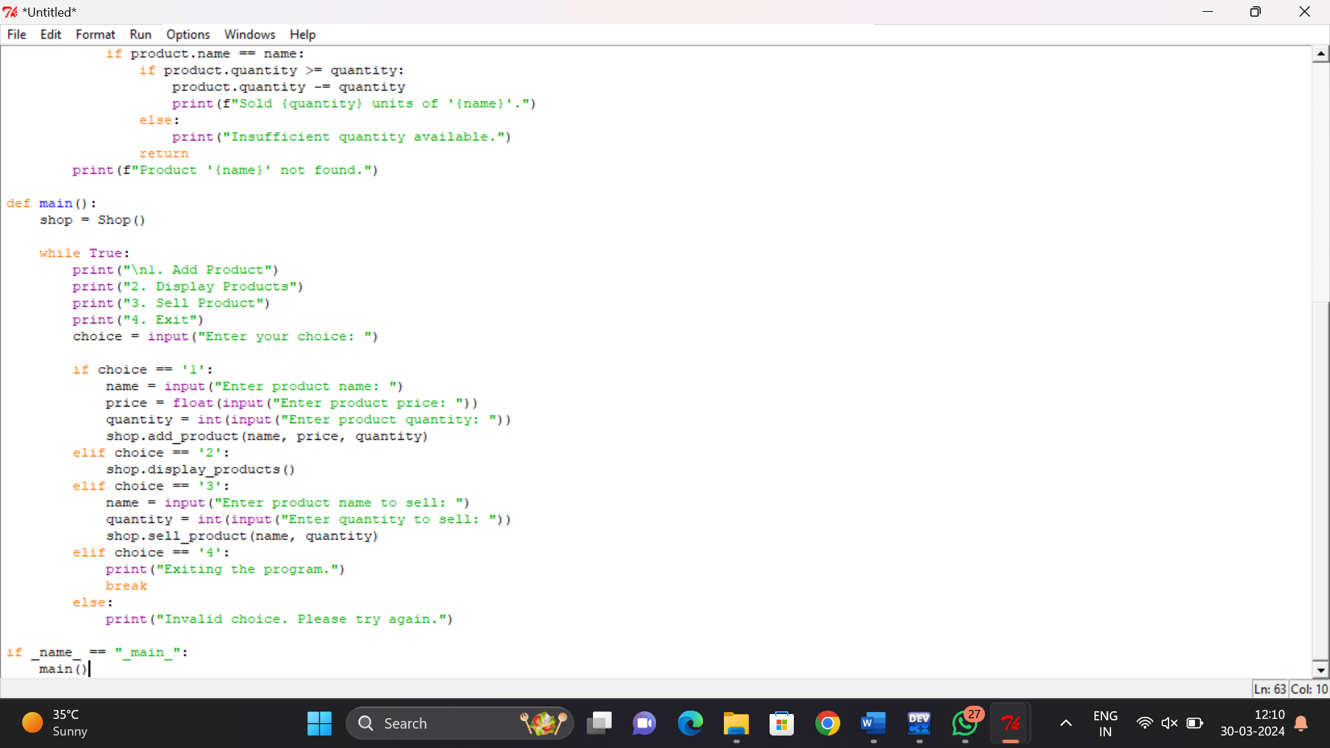

**1. *Product Class*:**

- Represents a product with attributes like name, price, and quantity.

- Initializes these attributes when a new product object is created.

**2. *Shop Class*:**

- Manages the shop's inventory using a list to store Product objects.

- Provides methods to add products, display products, and sell products.

**3. *add_product Method*:**

- Allows adding a new product to the inventory list.

- Creates a new Product object with the provided details and appends it to the products list.

**4. *display_products Method*:**

- Displays the list of products in the inventory.

- Checks if there are no products and prints a message if so.

- Iterates through the products list and prints the details of each product.

**5. *sell_product Method*:**

- Simulates selling a product from the inventory.

- Searches for the product in the products list by name.

- If found and the requested quantity is available, reduces the product's quantity.

- Prints success or error messages based on the outcome**.**

**6. *main Function*:**

- Entry point of the program.

- Creates a Shop instance and presents a menu for user interaction.

- Handles user choices by calling corresponding Shop methods or exiting the program.

**7. *User Interaction*:**

- Users can add products by providing details like name, price, and quantity.

- They can display the current product list or sell products by specifying the name and quantity.

- The program continues to display the menu until the user chooses to exit.

**7. RESULTS:**

Implementing the process produces a strong Shop Management System (SMS) adapted to the client's requirements. The SMS improves retail operations by optimizing inventory management, streamlining point-of-sale transactions, providing insightful sales data, improving customer relationship management, and supporting smooth multi-channel connectivity. It allows company to increase productivity, customer satisfaction, and profitability. The system's scalability, security, and user-friendly interface assure seamless operation and adoption. Overall, the SMS provides concrete benefits, such as higher productivity, decreased operational costs, and a competitive advantage in the evolving retail sector.

**8.DISCUSSIONS:**

The implementation of a Shop Management System (SMS) represents a significant advancement in modernizing retail operations and enhancing overall business efficiency. In this discussion, we delve into the various aspects and implications of integrating an SMS into a retail environment.

**1. Streamlined Operations:**

**By automating essential tasks such as inventory management, point-**of-sale transactions, and sales reporting, the SMS streamlines day-to-day operations. This streamlining not only reduces the time and effort required to perform these tasks but also minimizes the likelihood of human error. As a result, employees can focus on more value-added activities such as customer service, thereby improving overall productivity.

1. **Enhanced Customer Experience:**

The SMS plays a crucial role in improving the customer experience by enabling faster and more accurate transactions. With features such as integrated CRM, businesses can personalize interactions, track purchase histories, and offer targeted promotions, thereby fostering customer loyalty. Moreover, by ensuring that products are consistently available and reducing wait times at checkout, the SMS enhances customer satisfaction and encourages repeat business**.**

**3. Data-Driven Decision Making:**

One of the most significant advantages of an SMS is its ability to provide actionable insights through comprehensive sales reporting and analytics. By analyzing data on sales trends, inventory turnover rates, and customer preferences, retailers can make informed decisions regarding pricing strategies, inventory management, and marketing campaigns. This data-driven approach not only increases profitability but also ensures that resources are allocated effectively to areas with the highest potential for growth.

**4. Multi-Channel Integration:**

In today's omnichannel retail landscape, integrating multiple sales channels seamlessly is essential for staying competitive. The SMS facilitates this integration by synchronizing inventory across online platforms, brick-and-mortar stores, and other sales channels. This ensures a consistent and cohesive shopping experience for customers regardless of the channel they choose, thereby maximizing sales opportunities and expanding the reach of the business.

**5. Scalability and Flexibility:**

Another key advantage of an SMS is its scalability and flexibility to adapt to the evolving needs of a retail business. Whether a small independent shop or a large retail chain, the SMS can accommodate varying levels of complexity and volume of transactions. Additionally, its modular architecture allows businesses to customize features and add functionalities as needed, ensuring that the system r**e**mains relevant and effective over time.

**6. Challenges and Considerations:**

While the benefits of implementing an SMS are significant, there are challenges and considerations that businesses must address. These may include initial implementation costs, integration with existing systems, training employees on the new system, and ensuring data security and compliance with regulations such as GDPR and PCI DSS. However, with proper planning, investment, and support, these challenges can be overcome, and the long-term benefits of an SMS can far outweigh the initial investment**.**

**9.OUTPUT:**

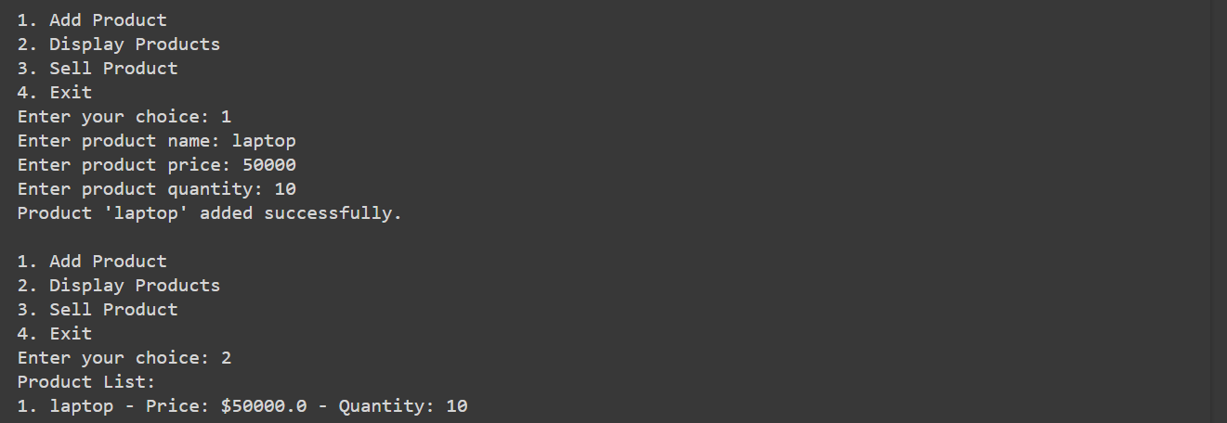

**10.CONCLUSION:**

In conclusion, the integration of a Shop Management System (SMS) represents a pivotal step forward in modernizing retail operations and maximizing efficiency. Throughout this discussion, we have explored the various aspects and implications of implementing an SMS, highlighting its transformative impact on both businesses and customers alike.

The adoption of an SMS fundamentally reshapes the landscape of retail operations, introducing automation and streamlining processes across essential functions such as inventory management, point-of-sale transactions, and sales reporting. By reducing manual effort and minimizing errors, the SMS frees up valuable time and resources, allowing employees to focus on more value-added activities such as enhancing customer service and driving sales. This not only boosts productivity but also cultivates a more engaging and satisfying shopping experience for customers, fostering loyalty and repeat business.

Furthermore, the integrated Customer Relationship Management (CRM) functionalities of an SMS empower businesses to forge deeper connections with their customers. By leveraging data insights and purchase histories, retailers can personalize interactions, tailor promotions, and anticipate customer needs more effectively. This level of personalized engagement not only enhances customer satisfaction but also strengthens brand loyalty, driving long-term profitability and growth.

One of the most significant advantages of an SMS lies in its ability to facilitate data-driven decision-making through comprehensive sales reporting and analytics. By analyzing key metrics such as sales trends, inventory turnover rates, and customer preferences, retailers can gain invaluable insights into their business performance. This enables them to make informed decisions regarding pricing strategies, inventory management, and marketing campaigns, ultimately driving profitability and ensuring sustainable growth.

**11.REFERENCES:**

1. Ghelani, D., & Hua, T. K. (2022). A Perspective Review on Online Food Shop Management System and Impacts on Business. Advances in Wireless Communications and Networks, 8(1), 7-14.
2. Ibodullayevich, Kalandarov Ilyos. "Human-machine tool shop management system." Middle Eur. Sci. Bull 5 (2020).
3. CHANDRAWANSHA, MWA. "COMPUTER SHOP MANAGEMENT SYSTEM FOR WISDOM COMPUTER TECHNOLOGIES." PhD diss., 2017.
4. Hannan, Ummae Hamida, Md Reaz Uddin Chowdhury, Md Goalm Rahaman, Sakib Mahmud Galib, and Md Taimur Ahad. "IoT based SMEs shop management system." arXiv preprint arXiv:2206.03580 (2022).
5. Nair, Rohan, Sreenivas Jayanth Yadhati, and Vaisakh KV. "Local E-Shop Management System for Pandemic Situation." In Proceedings of the International Conference on Innovative Computing & Communication (ICICC). 2021.
6. Gottschalk, Petter, ed. Knowledge Management Systems: Value Shop Creation: Value Shop Creation. IGI Global, 2006.
7. Rangkakulnuwat, Chainarong. "Jewelry shop management system." (2001)
8. Haupt, Reinhard. "A proposed shop management system for the engineering industry." the international journal of production research 27, no. 7 (1989): 1053-1063
9. Noraziah, A., Naimah, N., & Nasratun, M. (2008, August). Pet Shop Management System for Klinik Veterinar & Surgeri Jawhari. In 2008 International Symposium on Information Technology (Vol. 1, pp. 1-4). IEEE.
10. Jain, S. K. (1975). A simulation-based scheduling and management information system for a machine shop. Interfaces, 6(1-part-2), 81-96.
11. Torres, D., Pimentel, C., & Duarte, S. (2020). Shop floor management system in the context of smart manufacturing: a case study. International Journal of Lean Six Sigma, 11(5), 823-848.